101學年度「科技藝術專題講座」心得報告

THE RELATIONSHIP BETWEEN TECHNOLOGY AND ART.

Presenters. Ebrima Sambou and George Sambou.

演講者：Shih-Wei Sun, Ph.D. (孫士韋)  
Assistant Professor, Department of New Media Art (新媒體藝術學系助理教授)  
Taipei National University of the Arts, Taipei, Taiwan (國立台北藝術大學)

報告者：**Ebrma Sambou、Grorge Sambou**

INTRODUCTION.

Both science and art involves the systematic use of a technique or a skill and involves the testing of ideas and theories. Artists experiment in their studios while scientist evolve ideas in their labs. Both artists and scientists study materials, nature, and people to create something new. Science is a beautiful live example of art and art is an amazingly well laid out science experiment.

Leonardo da Vinci is perhaps our best example of someone who moved with ease between the worlds of art and science and transferred his studies from one to the other. His amazing scientific drawings are a work of art, and his paintings are the subject of many scientific theories.

**SUMMARY:**

In summary I would like to say that art has come along way for the fact that it started from caves in acient times and gradually to renaissance and to modern technology. Despite the limited resources the ancient people were able to keep us abreast with the way they lived and this has enabled us to compare and contrast the past and the present.

KEYWORDS:

Ancient

Renaissance

Modern

Technology –Photo tourism, graphic, desings.

**BACKGROUND.**

Prior to the invention of the camera and the use of advance pigment to represent images on surfaces pre-historic man used earth colors mixed with Animal fats to represent images of animals on the walls of caves later in the middle ages discoveries and inventions were made where man used superior pigments that were more illuminating and lasting. In the 13 Century there evolve a shift to perfection with the help of the chemically advanced scientific techniques to capture and represent images in high quality which saves speed, time and energy with the invention of the camera obscure, images were first produce in black and white using simple scientific techniques .

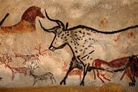

[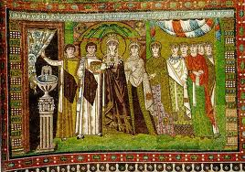](http://www.google.com.tw/imgres?imgurl=http://faculty.txwes.edu/csmeller/human-experience/ExpData09/03Biee/BieePICs/1ByzPICs/Ravenna/StVitale547/Theo01Ret497.jpg&imgrefurl=http://faculty.txwes.edu/csmeller/human-experience/ExpData09/03Biee/BieePICs/1ByzPICs/Ravenna/StVitale547/Theo01Ret497.htm&h=497&w=707&sz=172&tbnid=Ne7t02voyQJ71M:&tbnh=90&tbnw=128&prev=/search?q=The+Empress+Theodora+with+her+court+image&tbm=isch&tbo=u&zoom=1&q=The+Empress+Theodora+with+her+court+image&usg=___adwyVmX26-GKyYkcGvjgARCKL4=&docid=MwMZFkFH9gmcWM&hl=zh-TW&sa=X&ei=jS3XUMvhNIjFmAXl2YGIAQ&ved=0CDQQ9QEwAQ&dur=20)



Nuns in procession French, 1300.

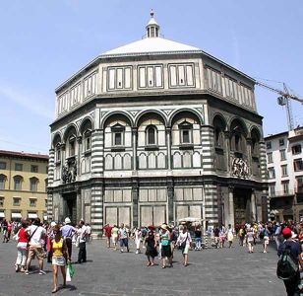

Architectural development



Lens based camera Obscura , 1

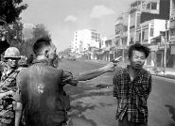

O Pulitzer prizing winning photographer Eddie Adams of his still photo which shows that still photos are the most powerful weapon in the world.

With the coming of computers, rapid and sophisticated objects are digitally captured and manipulated using tools and soft wares there by producing images of high qualities with creative possibilities, e.g from traditional computer image to state of the art photography which is 10 years ago. E.g 3D geometry and Physics combine.

According to professor Shih computer graphics creates great creative possibilities, easy to manipulate and requires tremendous expertise and work for realism whilst photography is instantly realistic easy to acquire and very hard to manipulate object or viewpoints.

Computational photography- refers to computational images capture and manipulation techniques that enhance and extend the capabilities of digital photography typically through the use of multiple pictures of the same subject matter such as using different exposed of the same scene to extend dynamic range be young even that of the analogue film based media. the output of the technique is an ordinary photograph but one that could not have been taken by traditional camera.

**Photo tourism** is a system for browsing large collections of photographs in 3D.

Show Video:

CONNECTION:

The subtopic: ‘’The history of visual media’’. Has a connection with both us for the fact that we came from fine art background to newmedia. Which involves the use of technology. Its like painting in caves to modern technology.

Q&A

END.

Nuns in procession French, 1300.

Said during the renaissance period there was great improvement especially in artichentic designs which he said too them 70 yrs adding that every part of the work is delicate.

They also depited how politics and religion clash inn some cases.

Realism later cae in where details were actually shown like color shadow etc.

Later in 1568 the sceintics camee in with the camera to record history improving from painting …an improvenment inother words.

During the 2world war the photo won an award the photos speaks for it self.

Not only the science but also artist record history. Present artist do thind which pple find hard to understand.

SUMMARY:

In summary I would like to say that art has come along way for the fact that it started from caves in acient times and gradually to renaissance and to modern technology. Despite the limited resources the ancient people were able to keep us abreast with the way they lived and this has enabled us to compare and contrast the past and the present.